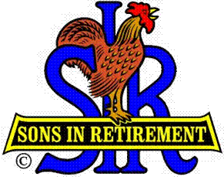
Las Trampas Branch 116
Luncheon Meeting Agenda
March 18, 2019, 11:30 AM

09:30 BEC Meeting
10:30 Social Hour
Greeters – Chris Doan & Chuck Vanoncini
Raffle – Duane Spencer & Alan Chasnoff
11:25 Five Minute Call
11:30 Call to order; Opening Remarks – Big SIR
Pledge of Allegiance -
Chaplain – Darrell McClaughry
Sunshine Report – Matt Arena
11:37 Story Teller – Roger Craig
11:41 Introduce Speaker – Lois Elling
Guests – Recruitment - Don Schroeder
Recognize Greeters – Jerry (Chris Doan & Chuck Vanoncini)
Awards – Allen Pirkle (90); Ben Smith (25 yrs); Dave Carlson (Apprec)
11:45 Salad Served
11:46 RAMP Department Heads Reports
11:53 Golf Committee Awards and Report – Bernie Wroblewski
12:00 Lunch
12:35 Activity Committee Reports
12:40 Speaker – Lois Elling – Appalachian Clog Dancing
13:20 Speaker Thank You
13:22 Raffle Drawing -
Birthday Drawing – Little SIR
13:25 Sing Happy Birthday - Music
Sing God Bless America
13:28 Closing Remarks – Big SIR
13:30 Adjourn; Next Meeting, April 15, 2019, Tax Day

